NAME___________________
Directions-Draw a picture of what molecules look like in each state of matter.
SOLIDS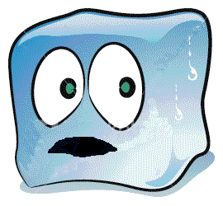 | LIQUIDS | GAS